

**Submitted by : Spogmai Jan**

**Roll No : 2430 - 0081**

**Submitted to : Sir Bilal Dar**

**Subject : Programming Fundamental Lab**

**LAB TASK :06**

**Task 01 : FOR LOOP**

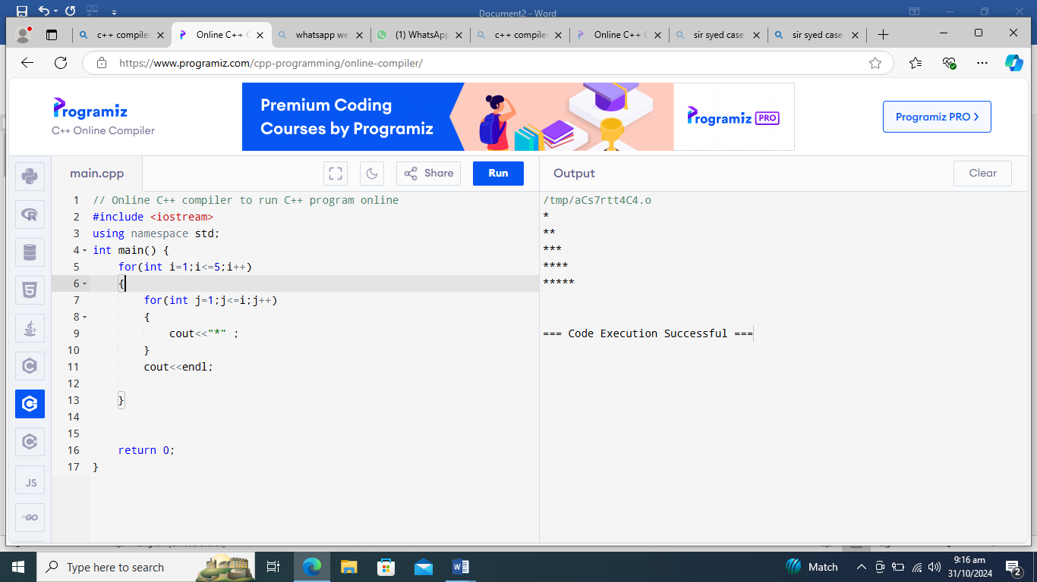

**While LOOP**

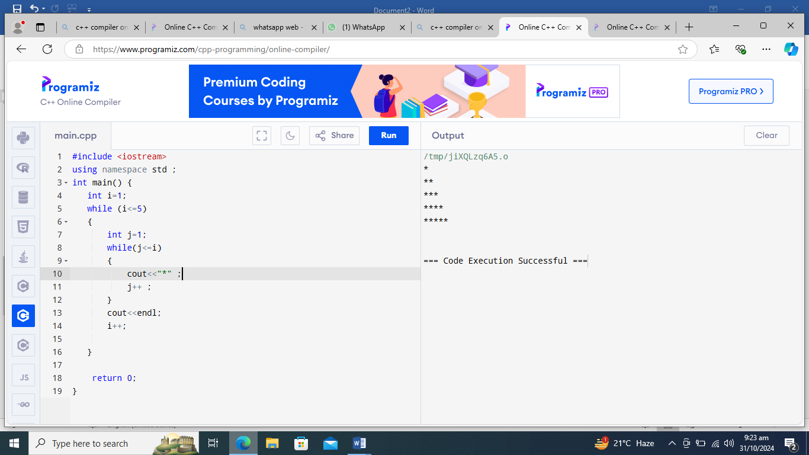

**Task 02 : FOR LOOP**

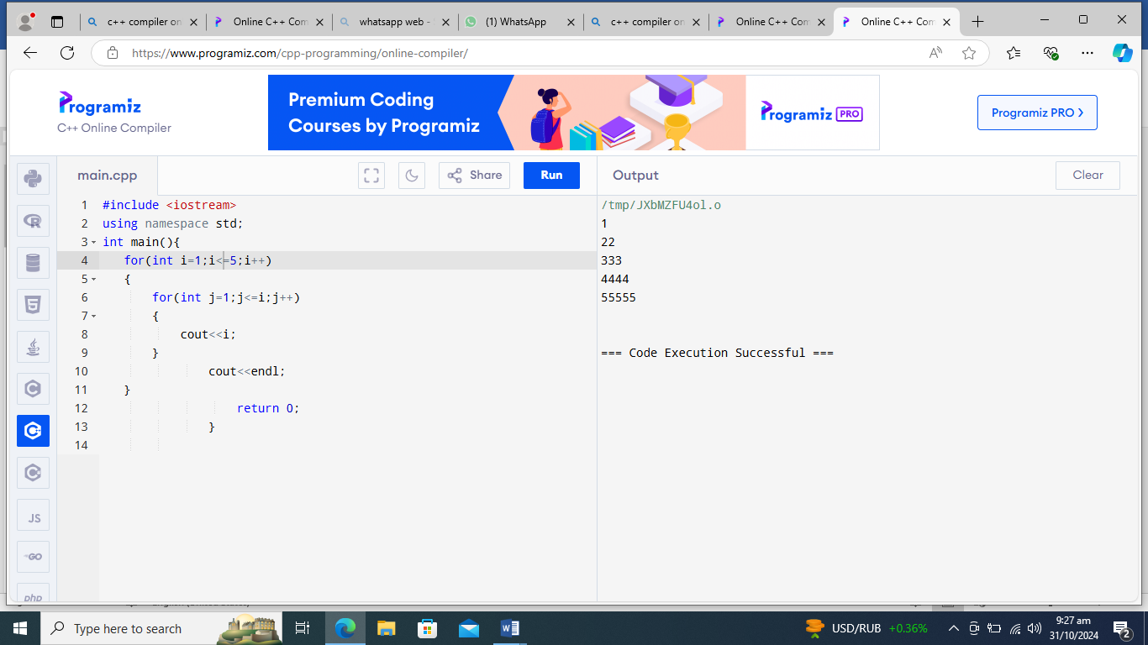

**While LOOP**

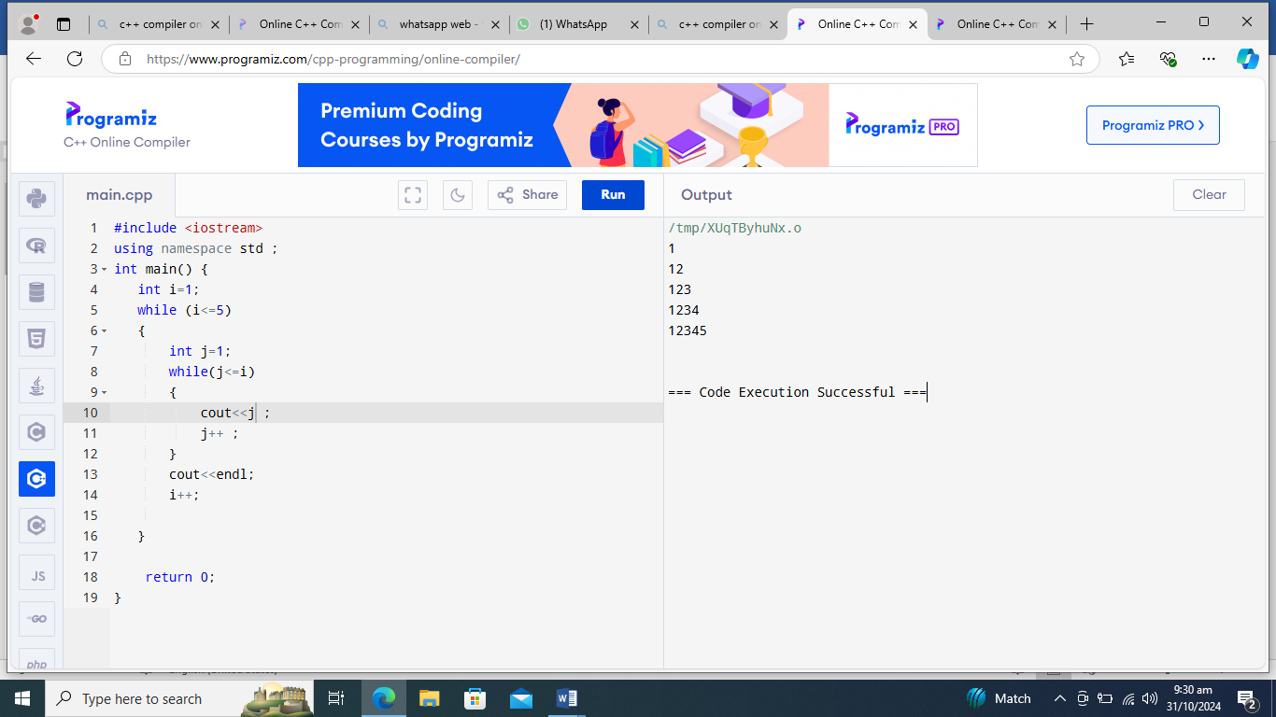

**Task 03 : FOR LOOP**

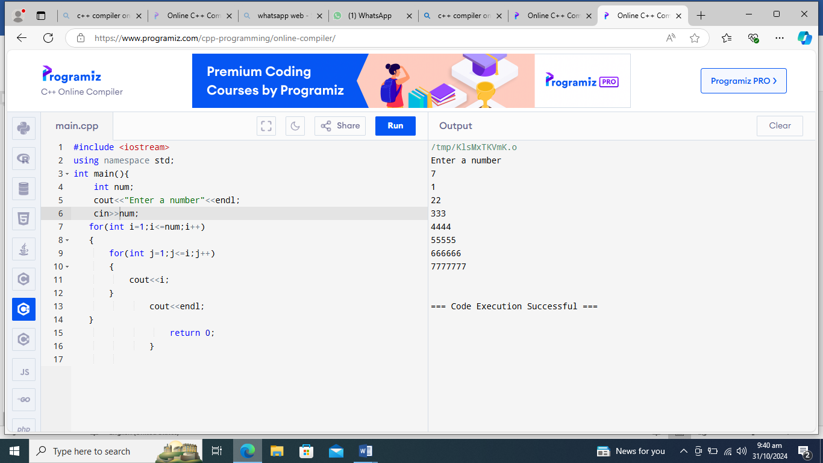

**While LOOP**

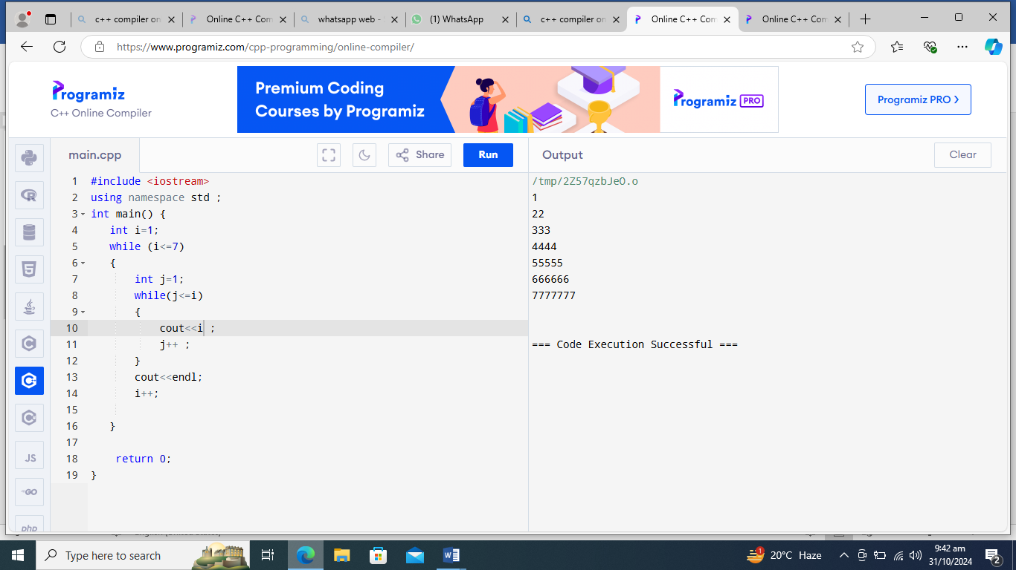

**Task 04 : FOR LOOP**

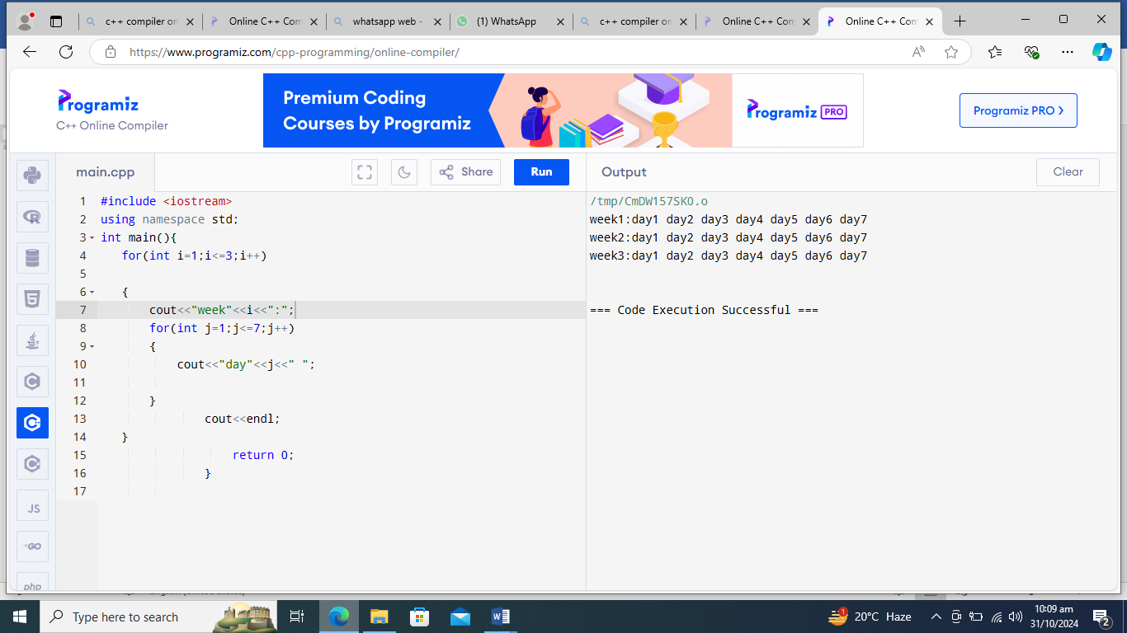

**While LOOP**

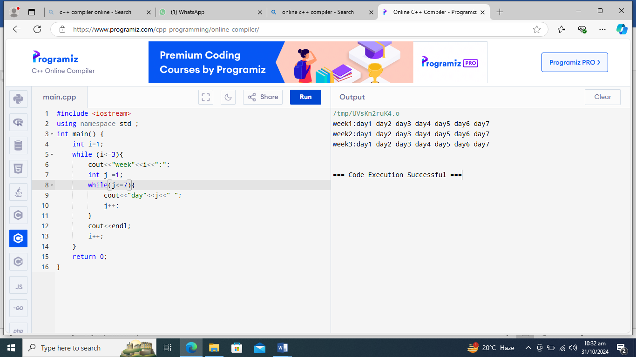

**Task 05 : While LOOP**

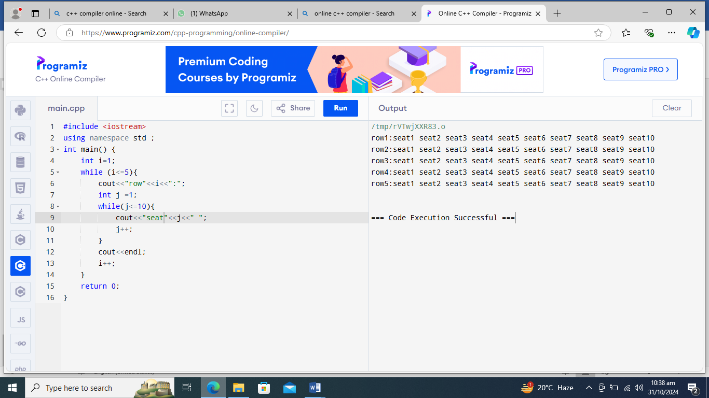

**For LOOP**

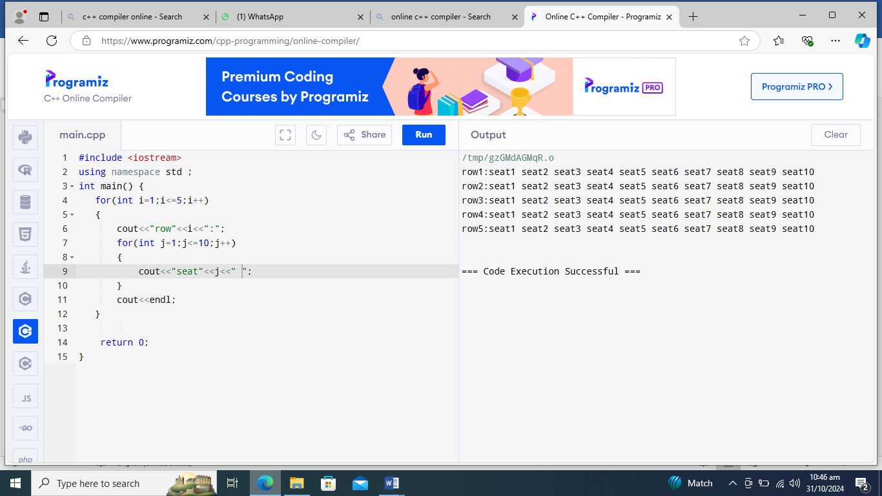

**----- THE END ----**